SEPTEMBER 2020 CAMBRIDGE LOCKSMITHS LTD.

Yale Keyless Access Entry Locks

Yale Assure SL
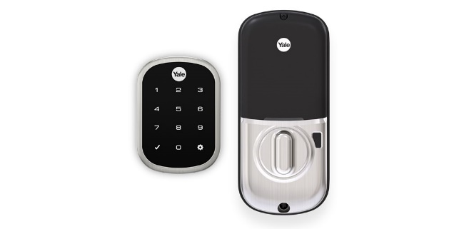YRD256NRSN $265.00 + GST = $304.75
Yale Assure Lock™
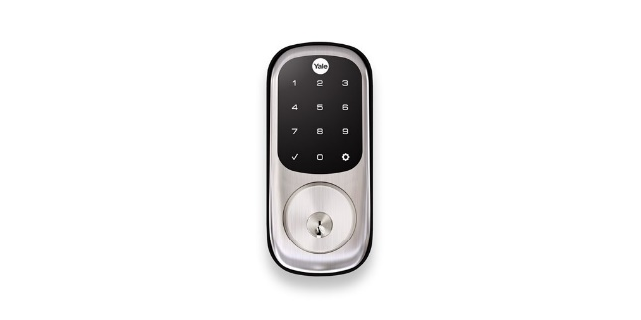YRD226NRSN $280.00 + GST = $322.00
Yale Assure Digital Lever
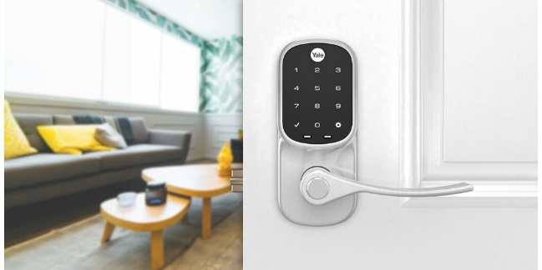YRL256NRSN $280.00 + GST = $322.00

YD-ACCESSKIT Yale Access Kit (Access Module, Connect Wi-Fi Bridge & Door Sensor) $170.00 + GST = $195.50

https://www.yalehome.co.nz/en/products/products-categories/keyless-entry/yale-access/

https://www.yalehome.co.nz/en/products/products-categories/keyless-entry/yale-access/yale-access-overview/

https://www.yalehome.co.nz/Yale/yalehomeCONZ/Product/Yale%20Access%20Home/YA-Access%20Kit%20Flyer.pdf

